*A CAL Project Report*

on

HOTEL MANAGEMENT SYSTEM

*to be submitted in partial fulfilling of the requirements for the course on*

**Database Management Systems – CSE2004**

**(D1)**

by

**Yashi Shukla 19BCI0188**

**Lagan Gupta 19BCE2057**

**Rishin Pandit 19BCB0116**



Fall Semester 2020-2021

**TABLE OF CONTENTS**

1. Introduction ……………………………………………………………. 01
2. Review 1 (Survey, Analysis)...………………………………….……… 04
3. Review 2 (Design of Diagrams & Prototype Design)………………….. 06
4. Review 3 (Development of Model).....…………………………………. 08
5. Conclusion ………………………………………………………....…… 11
6. References ………………………………………………………………. 12

**ABSTRACT**

A Hotel management system is a computerized management system. This system keeps the records of hardware assets besides software of this organization.

The knowledge and understanding of quality standards of guests helps hotel managers improve the quality of hotel services and increase guests’ satisfaction with the hotel stay. Different aspects of a hotel offer participate in the guests’ evaluation of the hotel experience. In order to be aware of the strengths and weaknesses of their businesses, hotel management has to identify which improvements in the hotel operations can bring additional value to their guests.

The environment in which hospitality businesses operate nowadays has become radically connected to the use of the Internet. An increase in the usage of Social Media triggered extreme changes in the information channels that hotel guests use in order to make booking decisions. Hence, the hotel management should be aware that travel information websites present a valuable source of information about customer preferences.

Main objective of this project is to provide solution for hotel to manage most there work using computerized process. Hotel room management system through the collection of information, transmission, sorting, processing, maintenance and use, improve the management level and efficiency, so as to achieve the automation, standardization and humanization of hotel management.

This Hotel Room management system uses the frontend technologies and MySQL database. The system cares about all the requirements of costumers and has the functions of reservation, checkout, settlement and review. With this system, hotel room can be managed conveniently and quickly, which greatly help the hotel industry to boom.

**INTRODUCTION**

The Hotel Room Management System addresses the following problems in very effective manner which was very tedious and time consuming in an offline mode. Hotel management project provides room booking, staff management and other necessary hotel management features. The system allows the manager to post available rooms in the system. Customers can view and book room online. The system is hence useful for both customers and managers to portable manage the hotel activities.

**Problems in Existing System-**

• The existing system in the hotels is manually working.

• Lots of time is required to do manual work.

• Searching is difficult.

• Data entry is difficult.

• Security is low.

• Doing calculations are hard.

**OBJECTIVES**

1. Implementation of hotel room management system by analysing the market demand.

2. To enable online booking via the internet hence people from faraway places can also efficiently book into the hotel.

3. To realize the function of user log in.

4. To maintain guest check out module to check out the room and pay the bill.

5. To set up business query model which realizes check-out query, instore guest query, out-of-store guest query, all guests query.

6. To realize customer management module to easily add, modify and delete members.

7. Easy update of the guest records.

8. High customer service standards attract more guests to the hotel.

**DATA COLLECTION**

**On Administrator end:**

* Should be able to make reservations
* The administrator can have access to book and unreserve rooms as per the requests through the interface.
* The Administrator should be allowed to change the status of the rooms like booked, vacant and other details like price, beds, air-conditioned or cooled.
* The administrator should be able to take the information from the customer and change it if required.
* The Aadhaar card details, Name, rooms booked, payment status Administrator will have the access to see the status of rooms and details of the customer staying in the rooms.

**On the Customer end:**

* The webpage appearing at the customer’s end should contain menu to view available rooms and its details including price, beds, air-conditioned or cooled.
* When the request for reservation is made, it is sent to the Admin for confirmation and then only the payment is made.
* Only after payment is made for room, then the customer can access services and food services.
* Should also contain the option to make reservations and make payments
* The details of the customer like Aadhaar card details, Name should be taken while making the reservations.
* For payments, the credit or debit card details will be recorded and saved and message will be displayed.
* Once booking is confirmed, the booked room details will be visible to the customer.
* The customer can choose to eat among the list of restaurants shown to the customer for the hotel. The restaurants will further have meal for which amount will be charged and added to additional amount.
* The customer can opt for services which will be provided by staff and an amount will be charged for these services which will be added to the ‘additional amount’.

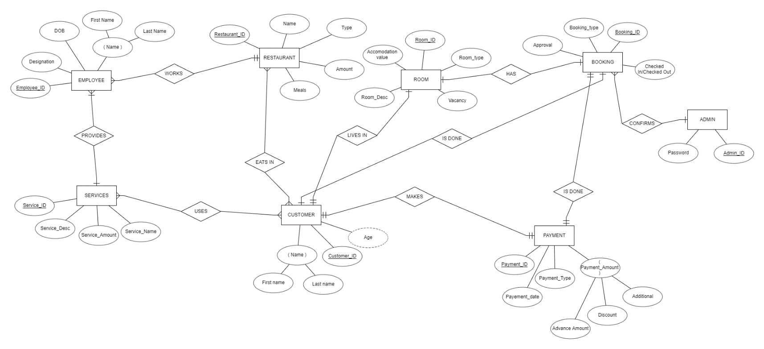**ER DIAGRAM OF HOTEL MANAGENT SYSTEM**

**Entities description**

1)**Employee** entity will be used to record the details of the employees working in the hotel.

2)**Services** entity will be used to keep track on the services being provided to the customers who are staying in the hotel.

3)**Booking** entity will record the bookings made by the customers online for a room in the hotel.

4)**Payment** entity will store the payment details of the customer including an advance amount, fees of all the services and discount if given.

5)**Customer** entity as similar to Employee will be used to store the details of the customers who have checked in to stay at the hotel.

6)**Room** entity will record the details of the room and the customer who is staying in the room.

7)**Restaurant** entity will record the restaurants in the hotels where the customers can have their meals.

8)**Admin** entity is responsible for confirming the booking made by customers to check in and stay in the hotel. The admin has the power to accept or decline the booking from customer.

**Relationships Description:**

1)**Provides**- it is a binary, many to one relationship from employees to services. This relationship denotes the services which will be offered by the employees to the customers of the hotel.

Each employee must provide a service, due to which there is total participation in employee side.

2)**Works**- it is a binary, many to one relationship between employees and the restaurants in the hotel. Each hotel must have an employee but it is not compulsory for an employee to work at a restaurant due to which there is total participation in restaurant side.

3)**Uses**- it is a binary, many to many relationship between services and customers. Each customer can use multiple services and each service can be used by multiple customers. It is not necessary for a customer to use any service due to which there is partial participation from both sides.

4)**Makes**- it is a binary, one to one relationship between customers and the payments which they make. Every customer will make a payment only once which includes the total amount to be paid by using different amount attributes of services and restaurant entities in the database. It is compulsory for a payment to be made by a customer and each customer must make a payment, hence there is total participation from both the ends of the relationship.

5)**Eats in**-it is a binary, many to many relationship between customer and restaurant of the hotel.

Many customers can eat in one restaurant and one customer can have their meals in different restaurants.

6)**Is done**- it is a binary , one to one relationship between payment and booking. A booking is only confirmed from the hotel management when a successful payment is made from the customer side of a certain advance amount. Each booking is unique to the payment and there is total participation from booking and payment entities.

**7)Confirms**- is a binary, one to many relationship from admin to booking entities. An admin can either accept or decline many bookings from different customers but one booking can be handled by one admin at an instance of time.

**CONCEPTUAL DIAGRAM**

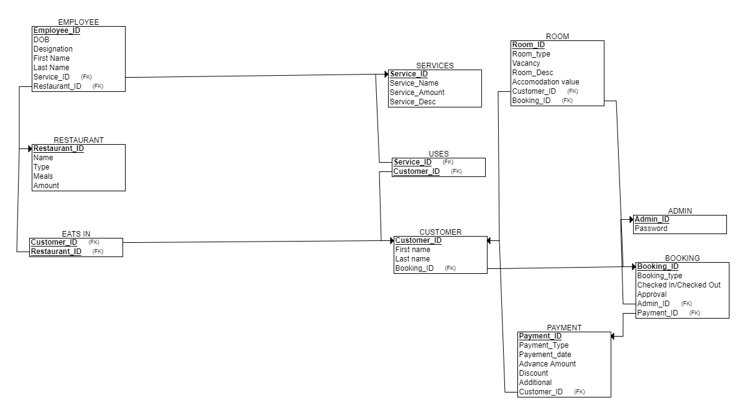**(WITH TABLE AND CONSTRAINTS)**

**Employee table:**

Employee_ID PRIMARY KEY varchar(7),

DOB date,

Desgination varchar(20),

First Name varchar(20),

Last Name varchar(20),

Service_ID varchar(7) FOREIGN KEY,

Restaurant_ID varchar(7) FOREIGN KEY

**Services table:**

Service_ID varchar(7) PRIMARY KEY,

Service_Name varchar(20),

Service_Amount int,

Service_Desc varchar(7)

**Room table:**

Room_ID PRIMARY KEY varchar(7),

Room_type varchar(20),

Vacancy varchar(20) CHECK(Vacancy in(“Vacant”,”Occupied”),

Room_Desc varchar(20),

Accomodation value int,

Customer_ID varchar(7) FOREIGN KEY,

Booking_ID varchar(7) FOREIGN KEY

**Customer table:**

Customer_ID varchar(7) PRIMARY KEY,

First name varchar(20),

Last name varchar(20),

Booking_ID varchar(7) FOREIGN KEY

**Payment table:**

Payment_ID varchar(7) PRIMARY KEY,

Payment_Type varchar(20),

Payment_date date,

Advance amount int,

Discount int,

Additional int DEFAULT 0,

Customer_ID varchar(7) FOREIGN KEY

**Admin table:**

Admin_ID varchar(7) PRIMARY KEY,

Password varchar(60)

**Booking table:**

Booking_ID varchar(7) PRIMARY KEY,

Booking_type varchar(20),

Approval varchar(20) CHECK(Approval in(“Confirm”,”Denied”)),

Checked In/Checked Out varchar(20),

Admin_ID varchar(7) FOREIGN KEY,

Payment_ID varchar(7) FOREIGN KEY

**Uses table(many to many relationship):**

Customer_ID varchar(7) FOREIGN KEY,

Service_ID varchar(7) FOREIGN KEY

**Eats in table(many to many relationship):**

Customer_ID varchar(7) FOREIGN KEY,

Restaurant_ID varchar(7) FOREIGN KEY

**Restaurant table:**

Restaurant_ID varchar(7) PRIMARY KEY,

Type varchar(7),

Name varchar(20),

Meal varchar(20),

Amount int

**References**

[1] Wei Wei, Zhengwei Lou. Design and Implementation of Hotel Room Management System. 2019 IEEE Symposium Series on Computational Intelligence (SSCI) December 6-9 2019, Xiamen, China.

[2] Jingda Yang. Research and Design of Hotel Management System Model. International Conference on Education Technology and Information System 2013.

[3] Ogirima, Sanni Abubakar Omuya. Online Computerized Hotel Management

System. Journal of Computation Biosciences and Engineering 2015 Science Q

[4] Smrita Singh, Shiv Prasad Kushwaha, Santosh Patnaik, Shweta Sharma. Development of Hotel Management Information System. IJESC 2016.